Long before Global Positioning System (GPS) arrived, researchers worked hard to arrive at a feasible solution to aid travellers from getting lost. Earlier, travellers used to rely on elaborate maps to track and monitor the route to their destination. But today, GPS technology has ensured hassle – free trips and increased safety for vehicle owners. The figure below illustrates a GPS satellite in orbit.

Introduction
GPS technology became a reality through the efforts of the American military, which established a satellite-based navigation system consisting of a network of 24 satellites orbiting the earth. GPS is also known as the NAVSTAR (Navigation System for Timing and Ranging).

GPS works all across the world and in all weather conditions, thus helping users track locations, objects, and even individuals! GPS technology can be used by any person if they have a GPS receiver.

Applications
This technique was initially developed for military applications. During 1980, the government decided to make it available for the civilian use as well. GPS has become an efficient tool in the field of scientific use, commerce, surveillance and tracking. GPS is used except in locations where it is difficult to detect the signal for example, underwater, subterranean location, inside the building and caves.

Civilian Applications
· Navigation – Used by navigators for orientation and precise velocity measurements.
· Geotagging – Map overlays can be created by applying location coordinates to photographs and other kind of documents.
· Surveying – Surveyors create maps and verify the boundaries of the property.
· Map-making – Used by civilians and military cartographers.
· Tectonics – Detect the direct false motion measurement in earthquakes.
· Geofencing – Vehicle, person or pet can be detected by using GPS vehicle tracking system, person tracking systems, and pet tracking systems.

Military Applications
· Navigation – Soldiers can find objectives in the dark and unknown regions with the help of GPS.
· Search and Rescue – Knowing the position of a downed pilot, its location can be traced out easily.
· Reconnaissance – Patrol movement can be handled.
· Target tracking – Military weapon systems use GPS to track air targets and potential ground before they are flagged as hostile.
· GPS carry a set of nuclear detonation detectors (such as optical sensor, dosimeter, electromagnetic pulse sensor, X-ray sensor) which is a part of United States Nuclear Detonation Detection System.
· Missile and projectile guidance – Targets military weapons such as cruise missiles, precision – guided munitions.
Structure of GPS
The GPS system comprises of three parts: Space segment, User segment and Control segment. The diagram of the structure of GPS is given below.

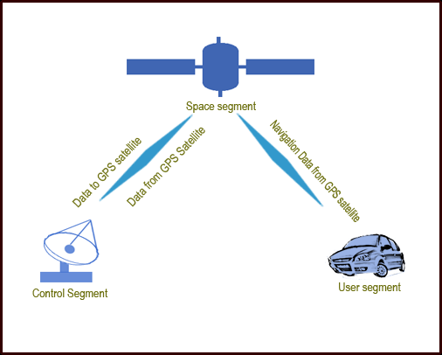

Space segment – The satellites are the heart of the Global positioning system which helps to locate the position by broadcasting the signal used by the receiver. The signals are blocked when they travel through buildings, mountains, and people. To calculate the position, the signals of four satellites should be locked. You need to keep moving around to get clear reception.

User segment – This segment includes military and civilian users. It comprises of a sensitive receiver which can detect signals (power of the signal to be less than a quadrillionth power of a light bulb) and a computer to convert the data into useful information. GPS receiver helps to locate your own position but disallows you being tracked by someone else.
Control segment – This helps the entire system to work efficiently. It is essential that the transmission signals have to be updated and the satellites should be kept in their appropriate orbits.

Working
The GPS satellites rotate twice a day around the earth in a specific orbit. These satellites transmit signal information to earth. This signal information is received by the GPS receiver in order to measure the user’s correct position. The GPS receiver compares the time a satellite transmits the signal with the time the signal is received. The time difference calculated enables us to know the distance of the satellite. By measuring the distance of few more satellites, the user’s position can be verified and displayed on the unit’s electronic map.

To measure 2D position and track movement, the GPS receiver must lock the signal of three satellites. The receiver can measure 3D position (latitude, longitude and altitude) if the GPS receiver locks the signal of four or more satellites.
On determining the position of the user, the unit of GPS can measure speed, trip distance, bearing, distance to destination, tack, time of sunrise and sunset, etc.

Types of GPS receivers
The three types of GPS receivers that offer different level of accuracy, and have different necessity to obtain the accuracies are:
· Coarse Acquisition (C/A) code receivers – These receivers offer 1-5 meter GPS position accuracy with differential correction. With an occupation time of 1 second, these receivers offer 1-5 meter GPS position accuracy. The GPS position accuracies can be within 1-3 meters consistently if the occupation time is long.
· Carrier Phase receivers – These receivers offer 10-30 meter GPS position accuracy with differential correction. The waves that carry C/A signal are counted to calculate the distance between the satellite and the receiver. High occupation time is required to obtain position accuracy.
· Dual Frequency receivers – These receivers offer sub-centimetre GPS position accuracy with differential correction. These receivers accept signals from the satellites on two different frequencies to find out accurate position.
Note: Differential correction is a method to compare GPS data collected in the field to the GPS data collected at a known point.

History
GPS was initially meant for military applications and was built by the American Department of Defence (DOD) in 1978. It was originally called NAVSTAR and was introduced with the launch of the first satellite.

Today, around thirty fully operational satellites orbit the earth covering a distance of 20200 km. These GPS satellites transmit signals which help locate the precise location of a GPS receiver. The latest in efficient satellite technology ensures that the GPS signal can be used without any fee by any individual in possession of a GPS receiver.

The predecessor of GPS used to be fixed radio stations spread across the globe in known locations. First, a master station sends out signals after which the slave stations across the globe start to respond. The slave stations send out these signals after a precise amount of time. The receivers then start to evaluate the time delay between the reception of the master and slave signals, thus determining a position relative to the slave stations.

Fixed radio station broadcasting was a problem for the military. This is the main reason why Transit, the first navigation satellite, was introduced in the 1960s. The location was determined with the help of a receiver, which calculated the Doppler Effect on the frequency broadcasted by the satellite to the frequency actually received. After this, the receiver closest to the satellite would get information and subsequent readings would precisely single out a location relative to the position of the satellite.

Modern satellites work differently to determine exact positions. A satellite signal would include the satellite’s position and the time of signal transmission. With this crucial information, the ground unit would be able to successfully locate a target swiftly and efficiently. Every satellite signal places the ground unit on a sphere from the satellite. The location of the GPS receiver is then identified as the intersection of the spheres (for additional satellite signals).

Interesting facts and figures
GPS has become more important in our daily life. New cameras that are launched have a built in GPS in order to give the information (latitude and longitude of where you were) when you take a photo and the information is stamped on the photo.
While driving it is difficult to concentrate on the GPS screen, and hence the developers launched a "Voice Guided GPS" in order to make it convenient and safer for the driver. The GPS now can provide information on where to turn, distance remaining to reach your destination, etc. Other units of GPS are voice controlled. You can give voice commands to find an alternative route. This makes the technology quite an interesting one.

GPS is very useful to hikers. The GPS will show the street you are on, can mark the location of hotel and places to be visited which could save your time rather than spend your precious time in finding the route.

GPS is a essential if you plan to go hunting, fishing, exploring, hiking, etc. and especially if you are not quite familiar with the region. The units of GPS for hikers are lightweight, compact and waterproof as well.

Important dates
Dates
1973 | Decided to launch a satellite navigation system (depending on Transit, Timation, 621B systems of the US navy and Air force)
1974 – 1979 | System Tests were conducted
1977 | Before the first satellites were positioned in the orbit, the first receiver tests were conducted. Transmitters called as Pseudolites are installed on the surface of the earth.
1978 – 1985 | Launching of 11 Block I satellites
1979 | Programs were redesigned to expand the GPS. Initially, 18 satellites were operated and then during 1988 it was raised up to 24 to satisfy the required functions.
1980 | First Block I satellite launched which contained sensors to detect atomic explosions.
1980 – 1982 | Critical financial situation came up and the sponsors had a doubt regarding the usefulness of this system
1983 | GPS system was made available to the civilians when the civilian aircraft of the Korean Airline was shot and was unable to detect its location.
1986 | The space shuttle “Challenger” was supposed to transport Block II GPS satellites but since it failed to do so it created a remark for GPS program.
1989 | Installation and activation of first Block II satellite
1990 – 1991 | During the gulf war, selective availability (SA) was temporarily deactivated. In July 1991, SA was activated again.
1993 | Announcement of Initial Operational Capability (IOC). It was also authorized to make it available free of charge to the civilians.
1994 | Satellite constellation completed for the last Block II satellite.
1995 | Announcement of Full Operational Capability (FOC).
2000 | Deactivation of Selective Availability (SA) which improved the accuracy for civilian use from about 100m to 20m.
2004 | 50th GPS satellite launched.
2005 | First IIR-M GPS satellite launched. This type of satellite supports the second civil signal L2C and military M signal.

Latest/Current Research and Key developments
In the mobile phone domain, GPS receivers are very much in demand today. In a few years from now, all GSM phones are expected to be fitted with superior GPS technology to help the user in navigation. This superior GPS technology will also help track other GPS-mobile enabled users. For example, anxious parents can keep a tab on the movements of their children. It also helps to keep track of individuals working in high-risk areas.

Another important feature is the GPS-enabled theft-protection systems that are very much in demand these days. This helps motorcycle and automobile manufacturers to locate stolen vehicles with pinpoint accuracy.

A big boost is provided to computer users in the form of Bluetooth GPS receivers. These receivers score over traditional connections because a cable is not required.
GPS is also being introduced into supply chains, to ensure that all goods are transported without hassles and are free from theft.

Problems being faced today
The most common problem that arises with the GPS system is accuracy. Accuracy depends on the signal that is sent by the time unit. The accuracy gets disturbed if the time is off in the GPS unit. The time and calculations are affected when it encounters rough atmospheric conditions. Inaccuracy occurs when a signal is bounced back from mountains, skyscrapers etc.

Another problem is related to its position that gets updated every twelve minutes. Once the signal has reached the updated time, the satellite is unable to know the correct location and can make calculation on based on the wrong information. This kind of errors is unavoidable.

GPS
In a simplest way ‘The Global Positioning System (GPS)’ is a satellite-based navigation system that consists of 24 orbiting satellites. This satellite transmits an amount of information in string format (e.g.: latitude, longitude, altitude, time etc.) which we are going to cover further.

GPS Receiver
GPS Receiver received the information in string format, transmitted by Satellites, which uses this information to calculate different parameters between it and satellites. With information from satellites, a GPS receiver can fix its location on the ground from the known position of the satellites.
Now I want to drag your attention on the purpose of this project. In this project, we are going to display ‘Latitude & Longitude’ used for positioning of an object on the earth. So let’s talk about how a GPS receiver fixes its location on the ground, as i above said and the find the location of an object on the earth.

Position Locator
Let me tell you, if we want an object location on the earth, GPS receiver have to connect with minimum 3 Satellite at the point of time. Now i explain this in a simple way by the help of fig 1.1:
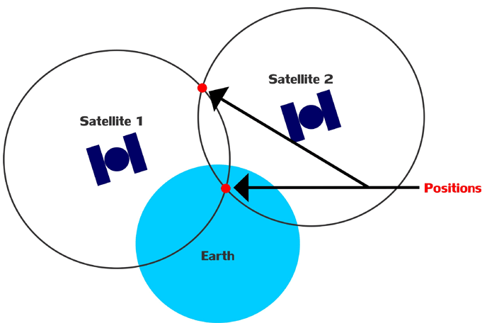

In Fig 1.1, I am trying to symbolize ‘Earth with a Sky Blue Circle’, ‘Satellites with Dark Blue’, ‘Satellites radius with Black outline circle’ and the ‘position with small Red circle’.
So let us assume we are standing on the earth with GPS Receiver and receiver is connected with two satellites- Satellite 1 and Satellite 2 at the time of instant. Both satellites have its own radius and after connecting with GPS Receiver, both radius will intersect with two points. This means we got two positions of us with respect to satellite at the same point of time which is practically not possible. So we will not able to fix our fix position in this case.
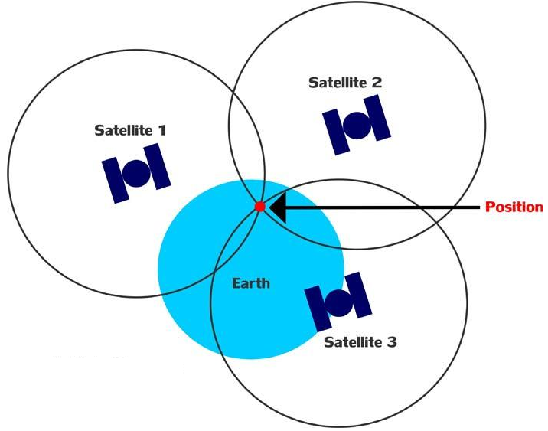

Problem solved. If our GPS receiver is connect with minimum 3 satellite at point of time, we got three radius by Satellite 1, Satellite 2 and Satellite 3, and all three radius will intersect in a common point and that common intersect point is our fix location on the earth with respect to satellites, that I meant in the starting of this section. I hope now you will be able to understand the concept.

INFORMATION TRANSMITTED BY SATELLITES
A list of information as string format given by Satellites as shown below in Table-1:
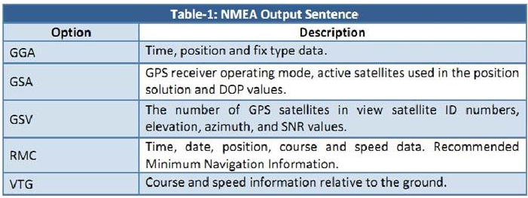
Along with this information, we need to find position which the ultimate purpose of our project, so we are going use only ‘GGA’ string. All string starts with ‘$GP’ which is a "talker ID" a two-character prefix that identifies the type of the transmitting unit. By far the most common talker ID is "GP", identifying a generic GPS. The detailed description of ‘$GPGGA’ string is given below in Table-2 and Table-3:
